**AGL needs Excel file**

M:\DISTRIBUTION\00A. CS Subs\20A-DRP\10-DIOR\20 - Advanced GL\2022\Wxx

**Stock needed** tab 🡪 *To show quantity missing for the next 8 weeks at subs level ( indep + dep needs)*

Cell highlighted in red: quantity is missing to fulfill the next 8 weeks needs

Cell highlighted in green: extra quantity after fulfilling the next 8 weeks needs

Cell highlighted in grey: no needs pulled in AGL OR the next 8 weeks needs = ATP subs + incoming shipment

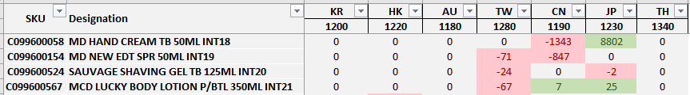

**Subs demand** tab 🡪 *Qties pulled in AGL for the subs*

1. Copy/Paste SKU + designation from AGL file (columns B:C)
2. Copy/Paste subs needs from AGL file (Columns AO, AQ, AS, AU, AW, AY, BA)

**ZPFR002** tab 🡪 *Qties needed by subs for the next 8 weeks*

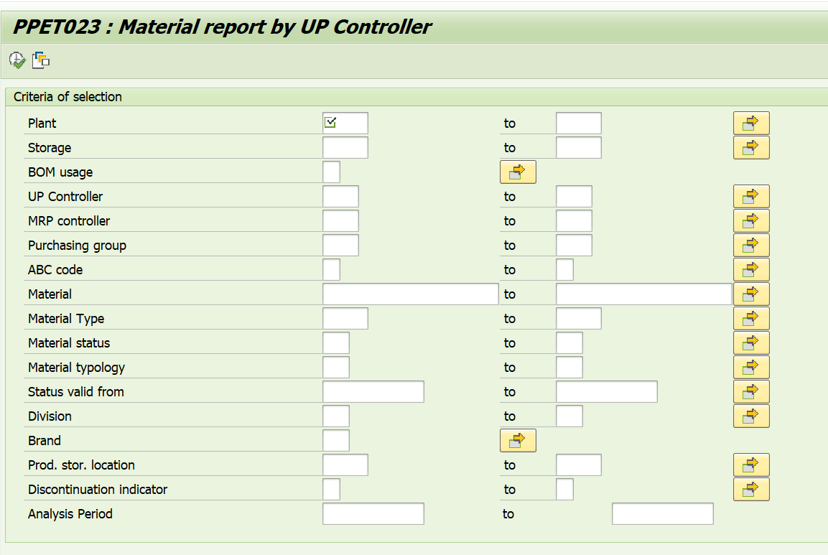

All SKUs in AGL

From beginning of the month to the next 8 weeks

All subs

**ZFRM004 PO no trst2920 to subs** tab 🡪 *POs created by CS but not yet in transit*

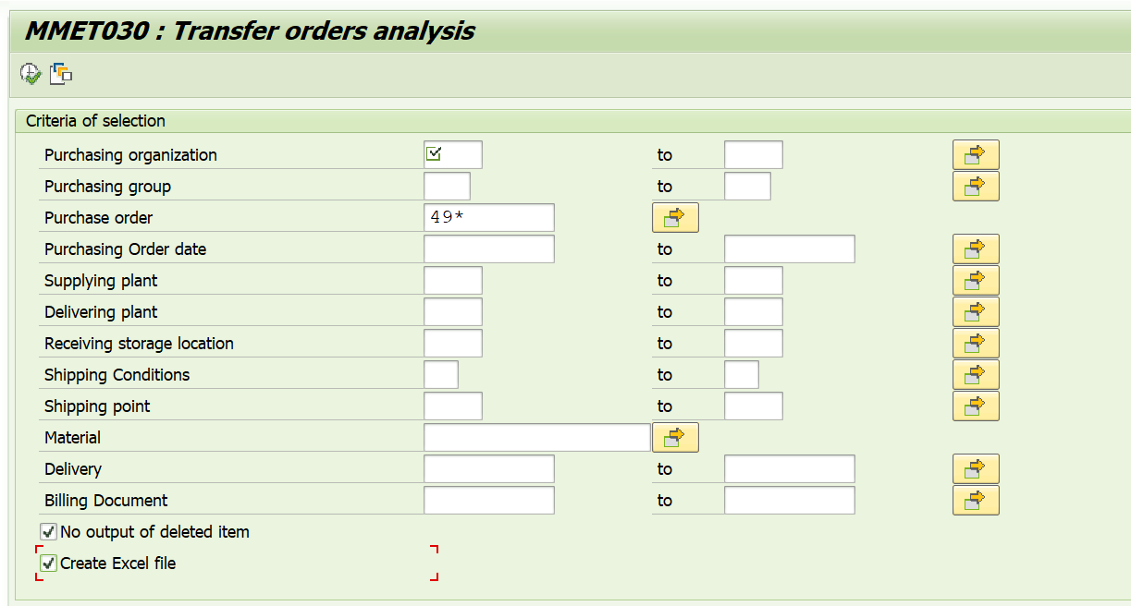

All POs

All SKUs in AGL

From beginning of the month to the next 8 weeks

All subs

1. Remove all lines WITH GI number in column W (=remove PO in transit)
2. Remove all lines WITHOUT BL numbers in column S (= remove PO not confirmed 🡪 Ord.DS)

**ATP** tab 🡪 *ATP stock for each subs*

Use variant “sg drp” and remove all material # and past all AGL SKUs.

Remove plant 2920, add the 7 subs codes.

